|  |  |  |  |
| --- | --- | --- | --- |
| VIIT Pune (@viit_pune) | Twitter | Bansilal Ramnath Agarwal Charitable Trust's Vishwakarma Institute of Information Technology  Department of  Artificial Intelligence and Data Science | | |
| Student Name: Siddhesh Dilip Khairnar | | | |
| Class: SY | Division: B | | Roll No: 272028 |
| Semester: 4th | | Academic Year: 2022-23 | |
| Subject Name & Code: ADUA22206: Web Technology | | | |
| Title of Assignment: Assignment No 7: Develop an application for a Library Management System using Node.js and MongoDB. | | | |

Aim: To perform MongoDB database connectivity.

Problem Statement: MongoDB database connectivity.

Code:

Dbconnect.js

var MongoClient=require('mongodb').MongoClient; var url='mongodb://localhost:27046/Moviee'; MongoClient.connect(url,function(err,db){

if(err) throw err;

var dbm = db.db("Moviee"); dbm.createCollection("Name_m",function(err,result){

if(err) throw err;

console.log('collection is created successfully !!!!!'); db.close();

});

dbinsert.js

var MongoClient=require('mongodb').MongoClient; var url='mongodb://localhost:27046/Moviee'; MongoClient.connect(url,function(err,db){

if(err) throw err;

var dbo=db.db("Moviee"); var record = [

{ "name": "Batman", "Rate": 9.4 },

{ "name": "Joker", "Rate": 9.3 },

{ "name": "300", "Rate": 8.7 },

{ "name": "The Green Knight", "Rate": 8.9 },

{ "name": "John Wick", "Rate": 9.9 }

];

dbo.collection("Name_m").insertMany(record,function(err,result){ if(err) throw err;

console.log("All Record inserted successfully !!!!"); db.close();

});

});

dbretrive.js

var MongoClient=require('mongodb').MongoClient; var url='mongodb://localhost:27046/Moviee'; MongoClient.connect(url,function(err,db){

if(err) throw err;

var dbo=db.db("Moviee"); dbo.collection("Name_m").find({}).toArray(function(err, result){

if(err) throw err; console.log(result); db.close();

});

});

Output:

dbconnect.js

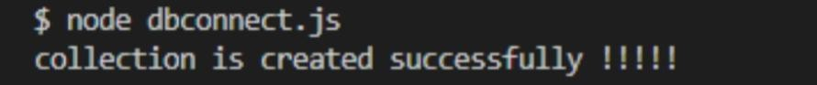

dbinsert.js

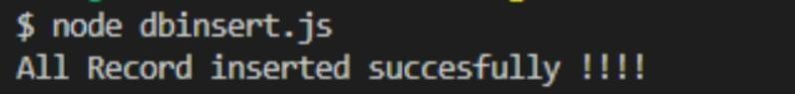

dbretrive.js

Conclusion: Thus, we successfully perform MongoDB database connectivity.